HIRING PROCEDURE



Revision History

Version | Date | Revision Author | Summary of Changes
1.2 | 10th June 2025 | Nisha Jaiswal | Yearly review for any updates.
1.1 | 16th June 2025 | Nisha Jaiswal | Yearly reviewed for any changes.
1.0 | 8th July 2023 | Nisha Jaiswal | 1st Draft

Approval

Name | Position | Date
Rajeev Jaiswal | Director | 17th June 2025
Rajeev Jaiswal | Director | 18th June 2024
Rajeev Jaiswal | Director | 14th July 2023

EMPLOYEE RECRUITMENT AND SELECTION POLICY
This Employee Recruitment and Selection Policy template is ready to be tailored to your company’s needs and should be considered a starting point for setting up your recruiting policies.

POLICY BRIEF & PURPOSE

Our employee recruitment and selection policy describes our process for attracting and selecting external job candidates. This recruitment policy sample can serve as a rubric that our recruiters and hiring managers can use to create an effective hiring process.

We are committed to our equal opportunity policy at every selection stage. Hiring teams should aim for a well-planned and discrimination-free hiring process.

SCOPE

This recruitment and selection policy applies to all employees who are involved in hiring for our company. It refers to all potential job candidates.

POLICY ELEMENTS

Generally, hiring teams could go through the following steps:

- Identify the need for an opening
- Decide whether to hire externally or internally
- Review the job description and compose a job ad
- Select appropriate sources (external or internal) for posting the opening
- Decide on the selection stages and possible timeframe
- Review resumes in company database/ATS
- Source passive candidates
- Shortlist applications
- Proceed through all selection stages
- Run background checks
- Select the most suitable candidate
- Make an official offer

Stages may overlap. Hiring managers may remove/add steps as appropriate. The first five stages are mandatory in every hiring process.

OVERALL HIRING PROCESS

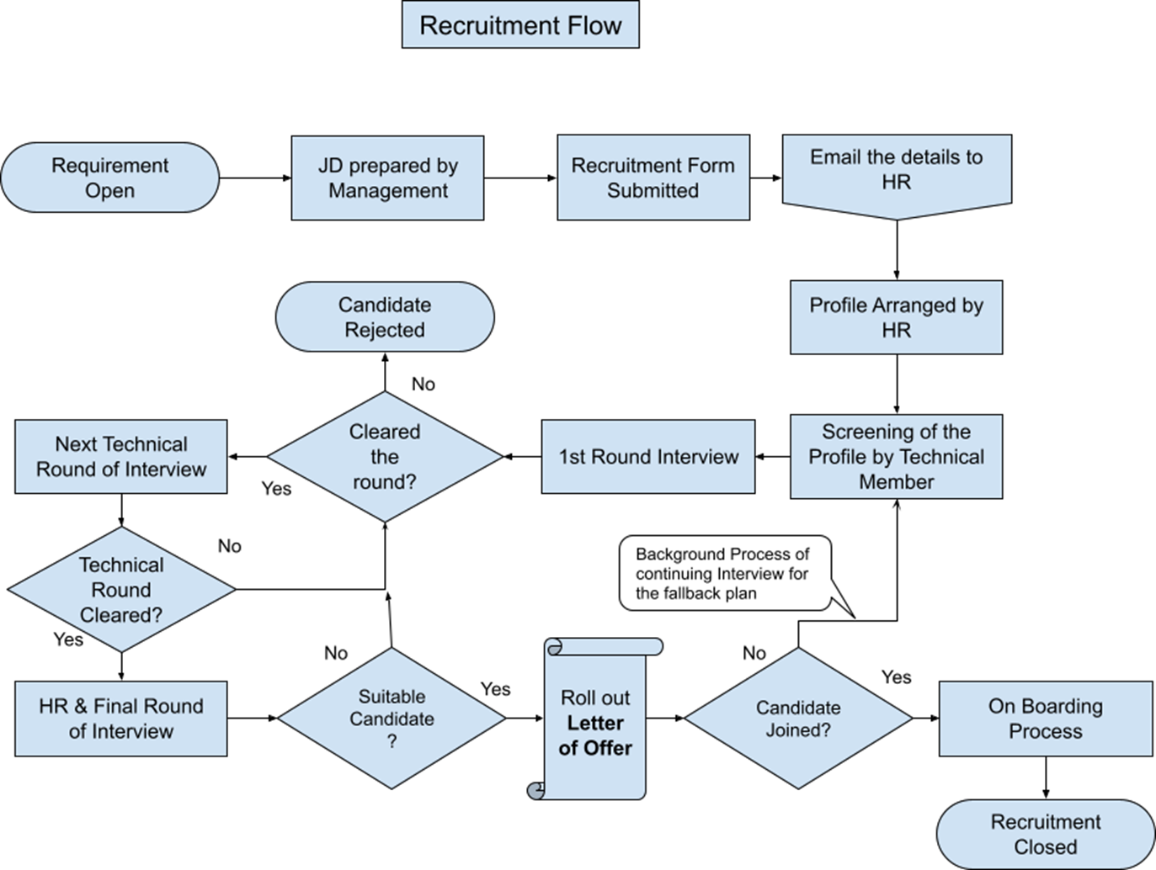

Posting jobs internally

Hiring managers can post a job opening internally before starting to recruit external candidates. If they decide to post internally, they can:

Set a deadline for internal applications
Communicate their opening through newsletters, emails, word-of-mouth, or an Applicant Tracking System’s automated emails

Creating job descriptions

Hiring managers can create job ads based on full job descriptions of each role. Job ads should be clear and accurately represent the open position. They should include:

- A brief description of our company and mission, A short summary of the role’s purpose
- A list of responsibilities, a list of requirements, and how to apply
- The job ad’s style should be consistent with our company’s unique voice. It should be addressed to ‘you’ in a polite and engaging tone. Jargon, complicated phrases, and gender-specific language should be avoided.

Employee selection stages

Our company has a standard hiring process that may be tweaked according to a role’s requirements. Our standard process involves:
- Resume screening
- Phone screening
- Assignment
- Interview
Hiring managers may choose to add/remove stages depending on the role they’re hiring for. For example, they can add the following selection stages/methods:

- Assessment Technical interviews
- Competency/Knowledge or other selection test
- Group interview/ Managerial Interview
- HR Interview
- Referrals Evaluation
In most cases, the stages of resume screening and interview are compulsory.

Interview feedback

Recruiters/ hiring managers should always inform candidates they interviewed that they decided to reject them. Leaving candidates in the dark can be damaging to our employer brand.

Also, we encourage hiring managers to send interview feedback to candidates. They should first check with HR to make sure they won’t invite legal action. Being brief, respectful, and keeping feedback job-related are the general rules for writing feedback emails to candidates.

Revoked offers

In case a formal has to be revoked, the hiring manager and the human resources department should draft and sign an official document. This document should include a legitimate reason for revoking the offer. Legitimate reasons include:

- The candidate has been proven not to be legally allowed to work for our company at a specific location
- The candidate has falsified references or otherwise lied about a serious issue
- Candidate doesn’t accept the offer within the specified deadline (deadline must have been included in the offer letter)
Hiring managers and HR must notify the candidate formally as soon as possible.

